**Zomato Data Analysis Project**

**Overview:**

Zomato has an average of 17.5 million monthly transacting customers for its food delivery business where average monthly active food delivery restaurant partners on zomato’s platform have also increased by 8.7% year on year, from 208000 to 226000. You are working in a data-driven role at Zomato. You have a dataset of customers. As a data professional, you need to analyze the data, perform EDA and visualization, and answer the following questions:

1. **What type of restaurant do the majority of customers order from?**

**Ans:**

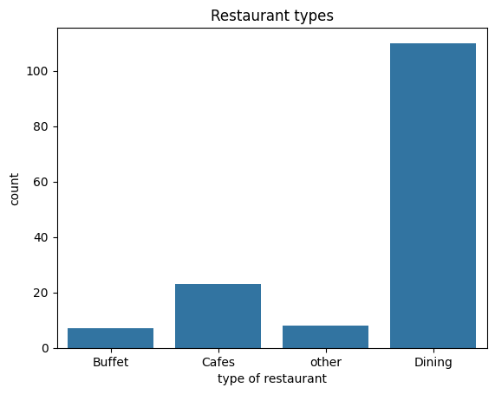

**Explenation:** I used a bar chart to show the type of restaurant from where customers ordered food the most. Here customers ordered food most from dining type restaurants.

1. **How many votes has each type of restaurant received from customer?**

**Ans:**

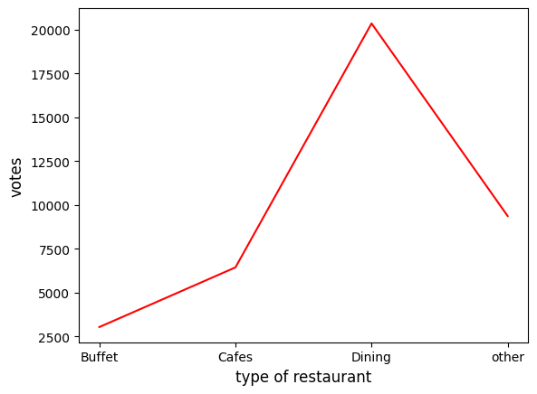

**Explanation:** I used line chart to answer this question. I can see dining restaurants get most of the vote from customers which is more than 20000 votes, second is other type of restaurants get more than 9000 votes and cafes, buffet restaurant get more than 6000 votes and 3000 votes respectively.

1. **What are the ratings that the majority restaurants have received?**

**Ans:**

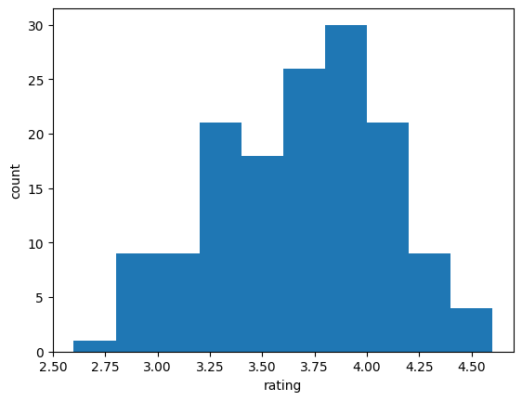

**Explanation:** I used histogram to answer this question. Majority of the rating is 3.75-4.05 have received by restaurants.

1. **Zomato has observed that the most couples order most of their food online. What is their average spending on each order?**

**Ans:**

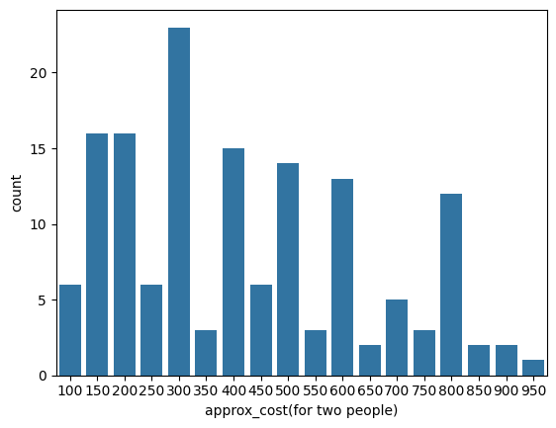

**Explanation:** I used bar plot to answer this question. We can see that the average order spend is 300 rupees done by couples.

1. **Which mode (online/ offline) receives maximum ratings?**

**Ans:**

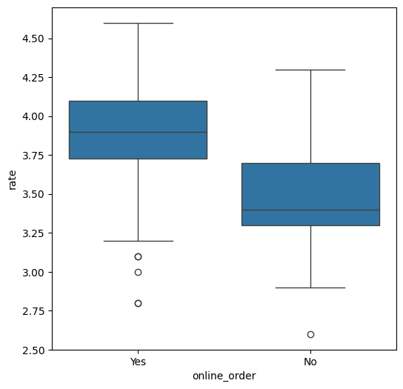

**Explanation:** I used box plot to answer this question. Offline order receives lower ratings compare to online orders.

1. **Which type of restaurant received more offline orders, so that Zomato can provide those customers some good offer?**

**Ans:**

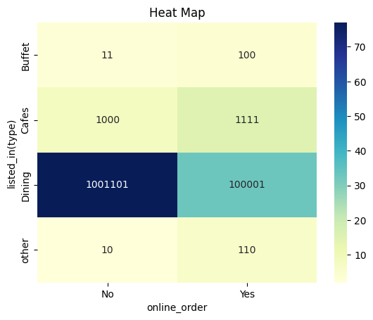

**Explanation:** I used heat map to answer this question. I can see dining restaurants primarily accepts offline orders, where as cafes receives online order. This shows that client prefers to visit dining restaurants but will enjoy café foods at home.